NSAA BASKETBALL
OFFICIALS’ CLINIC

The NSAA will be conducting a 3-Person Basketball Officials’ Clinic on November 25, 2006. The purpose of the camps is to train officials in 3-person mechanics. The NSAA will begin 3-person officiating for all post- season contests beginning in 2007. The clinic will consist of classroom instruction followed by court time observation and evaluation. Note: Priority for post-season contests in 2007 will be given to officials that have attended an NSAA sanctioned clinic.

3-Person Mechanics Clinic Lincoln North Star High School November 25, 2006

Classroom: 8:00 aM – 9:00 AM

Court Time: 9:00 AM -- ???

Registration Fee; $ 30.00 Non-Refundable
Lunch will be provided
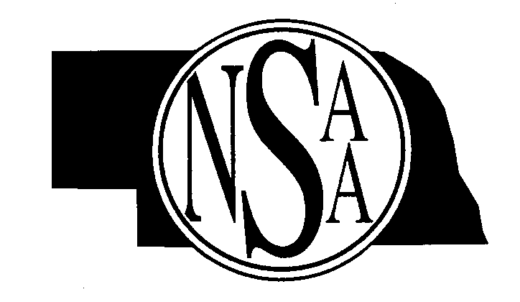
Evaluators and Clinicians: ENOA
Dick Zierke rzierke@neb.rr.com
Shane Smith ssmith6@neb.rr.com

Clinic will be limited to first 50 applicants.
_______________________________________________________________________________________________________

Complete the registration forms with all the necessary information and enclose payment of $30.00.

Return by November 17, 2006

Name____________________________________Address___________________________________________________

City____________________________State______Zip_____________________Telephone # ________________________

E-mail _____________________________

MAIL TO: NSAA
P.O. Box 5447
Lincoln, NE 68505-0447

